RESUME
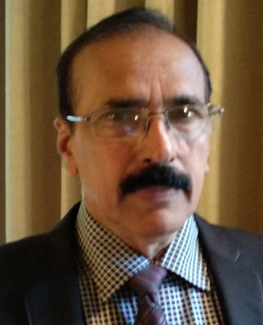 | Sarat Kumar Pani  Senior Manager (Retd),  Union Bank of India
Name, Address & Contact Number | Sarat Kumar Pani,  # 953, Sahadebkhunta,  P.O. / Dist. Baleswar  ODISHA – 756 001,  Mobile No. +91 94375 46310
Date of Birth | 9th May 1952
Educational Qualification | M. A.
Organization last served | Superannuated from Union Bank of India (E-Andhra Bank).
Work Experience | 35+ years Banking Experience in the field of High-Tech Agriculture Advances, Corporate Lending, Priority Sector Lending, Retail Lending, Monitoring of Advances, Recovery and Resolution of Stressed Asserts.
Worked as Branch Head (Rural, Semi-urban and Urban Branches) for 23 Years (1981-2004). Also worked in Inspection and Vigilance Departments of Head Office and Zonal Offices.

Was a Director of M/s Saiomm Seafood Exports Private Limited, an Exporter of Sea Foods. During 2018, left M/s Saiomm Seafood Exports Private Limited to promote another Company, Camaron Exports Private Limited.

