RESUME
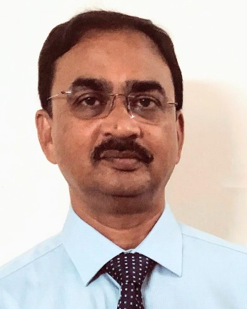 | Manoranjan Das  Dy. General Manager (Retd),  Indian Bank
Name, Address & contact Number | Manoranjan Das,  #903, Tower-1, Vipul Gardens, Kalinga Nagar,  Bhubaneswar PIN-751 003, State- ODISHA  Mobile No. +91 96875 80580
Date of Birth | 22nd April 1962
Educational Qualification | M Sc(Agril), CAIIB, LLB
Organization last served | Superannuated from Indian Bank (Erstwhile Allahabad Bank) Deputy General Manager.
Work Experience | 35+ years Banking Experience in the field of Corporate Lending, Priority Sector Lending, Retail Lending, Monitoring of Advances, Recovery and resolution of stressed Asserts.
Present Empanelment | Empanelled with IBBI (Insolvency and Bankruptcy Board of India) as Insolvency Professional to act as Resolution Professional, Liquidators, Bankruptcy Trustee under Insolvency and Bankruptcy Code 2016.

